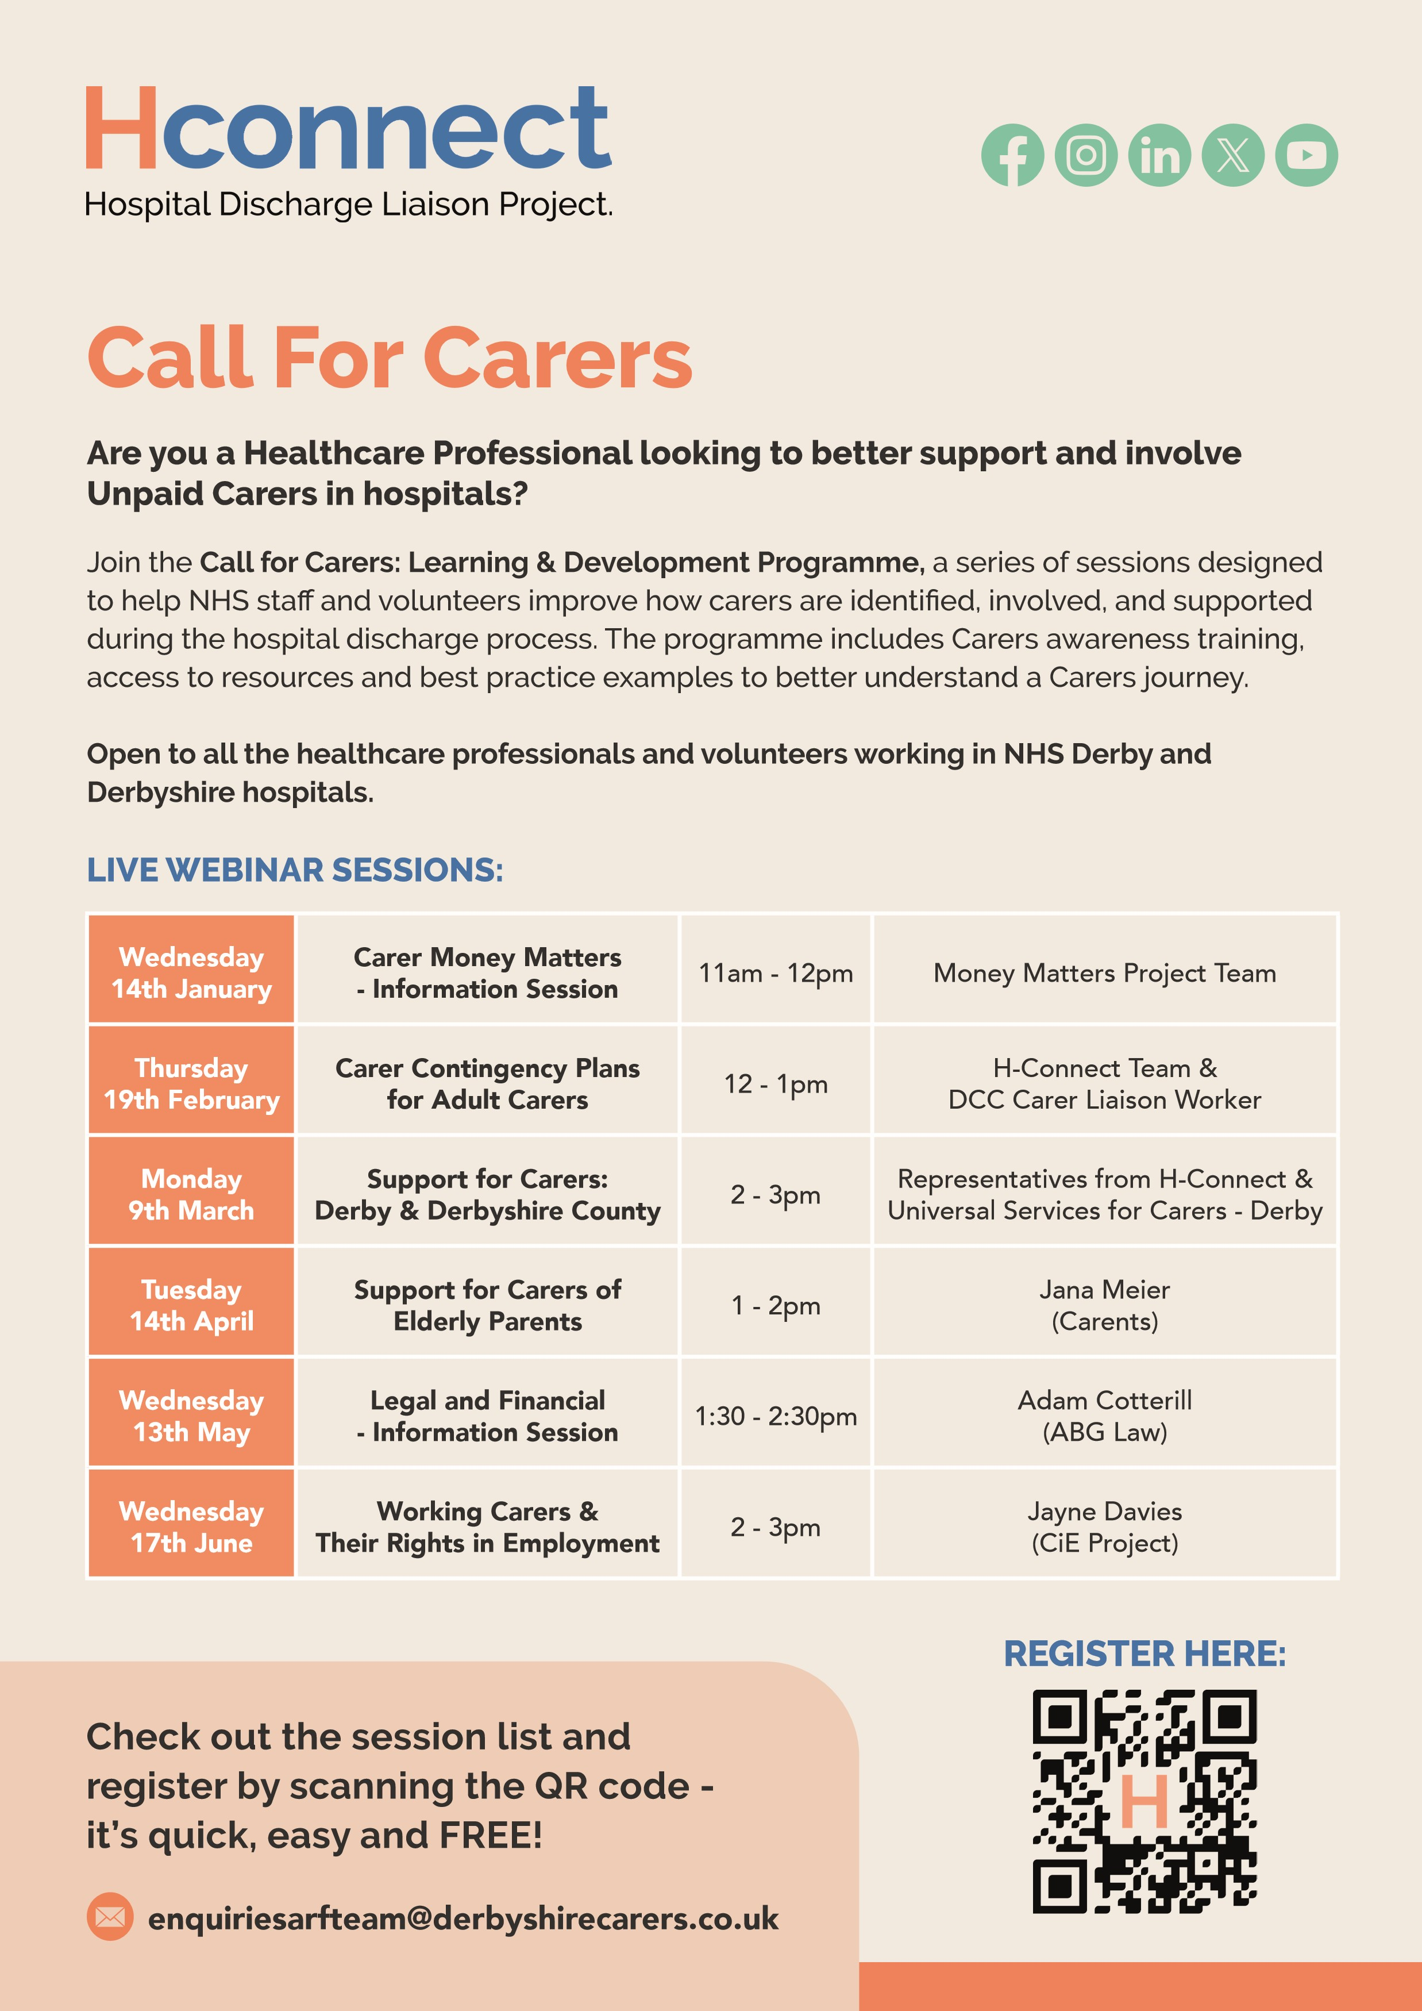
hconnect@derbyshirecarers.co.uk

